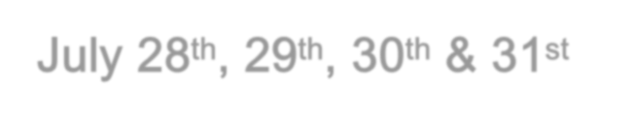2020 BLACK POWDER NATIONAL SILHOUETTE CHAMPIONSHIPS
July 28th, 29th, 30th & 31st
RIDGWAY RIFLE CLUB
DATES: July 28th & 29th BPCR Scope, July 30th & 31st BPCR Iron Sites
TIMES: The range opens at 8:00 AM. The Matches start daily at 9:00 AM.

PRACTICE: The range will be open for practice the 26th & 27th 8am until dusk. Range safety rules apply. Practice: 8:00 – 8:45 AM on event days. The range will then be closed end of day 7/31 until 8/8.

COURSE OF FIRE: 1- 60 shot match each day. Current NRA rules will apply.

NOTE: All shooters must have a spotter/scorer on the line with them; only one per shooter permitted on the firing line. Eye & Ear protection on the line is mandatory. Ammunition causing target damage will be disqualified. Match winner will be (5) shot shoot offs, Natl. Champion Teams will be (5) shots by each team member. Class & specialty awards will be sudden death.

ENTRY FEES: Adults $110. BPCR Scope & $110. BPCR Iron Sites. $200 for both. Juniors: Free
Make checks payable to: Ridgway Rifle Club.
Mail Entries to: Mike Haynes; Match Director. Contact information below.

ELIGIBILITY: The tournament is open to all. Your NRA classification card is required. If you do not have a card yet, YOU MUST BRING PROOF OF YOUR CLASS. (print offs from a club website showing scores from recent matches is proof) Unclassified shooters will compete in the highest class with participants.

REGISTRATION: Pre-registration appreciated & required by 7/1 for lunch planning, name tags & t-shirts. Thanks!

AWARDS: Match Winner, 2nd Open, 3rd Open. Class awards: M through B Class – three places. Two Gun grand aggregate, high Sub Junior, High Intermediate Junior, High Junior, High Woman & High Senior will be awarded.

LOCATION: Ridgway Rifle Club is located about 1.75 miles north of Ridgway, PA on Grant Rd.

GENERAL INFORMATION: The firing line is covered and additional shelter is nearby. There will be a lunch break during the day with $5-$8 lunch available for purchase. A complimentary cookout planned after the match on the 29th. Camping is available on club grounds, some with electric (first come basis) & plenty of primitive camping. A dump station for campers at main club house.
More information is available on the club website, www.ridgwayrifleclub.com (directions, lodging, etc.)

MATCH DIRECTOR: Mike Haynes
14 Looker Mountain Trail Bradford, PA 16701
Ph.: (814)596-2994
e-mail: Miketammy2@yahoo.com

